SOFTWARE REQUIREMENTS SPECIFICATION

for

Event Management System

Prepared by :-

1.Ganesh Mal .K

2.Parvadaesh.S

3.Rishievardhan.B

1.**Introduction**

1.1 **Purpose**

The main objective of this document is to illustrate the requirements of the project Event Management system. This document specifies the requirements of the Event Management system project. The project aims to develop a platform that facilitates the interaction between event hosts and participants. The platform can handle events of any size and complexity, such as conferences, festivals, trade shows, and professional meetings. The platform provides features such as event creation, registration, promotion, communication, feedback, and analytics. The platform also integrates with various external services, such as payment gateways, social media, and email providers. The platform is designed to be user-friendly, scalable, secure, and reliable.

1.2 **Document Conventions**

Entire document should be justified.

Convention for Main title

Font face: Arial

Font style: Bold

Font Size: 14

Convention for Sub title

Font face: Arial

Font style: Bold

Font Size: 12

Convention for body

Font face: Arial

Font style: Bold

Font Size: 121.3 **Scope of Development Project**

The Event Management system project is a web-based application that allows event organizers to update and manage their events online. The project provides a complete user interface for both event hosts and participants. The project can be customized according to the client's requirements and can streamline the event management process, enhance customer satisfaction, and generate valuable data for future event planning. The project also enables event hosts to create online registration pages for their events and allow participants to register through them. The project is flexible and adaptable to various situations. The project supports adding new features as needed, making it reusable and modular. The project is developed using Java as the programming language, as it offers several advantages over other languages, such as performance, tools availability, cross-platform compatibility, libraries, cost (free of charge), and development process.

1.4 **Reference**

Website:

* <https://www.scribd.com/document/532682522/Event-Management-System>
* https://github.com/HxnDev/Event-Management-System/tree/main/Enterprise%20Architect

2. **Overall Description**

**2.1 Product Perspective**

EMS

Figure 1:Use Case Diagram of EMS

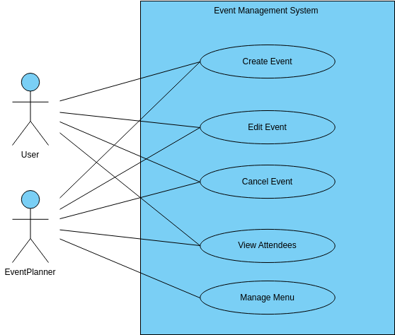

**2.2 Product Function**

Entity Relation Diagram of Event Management System:

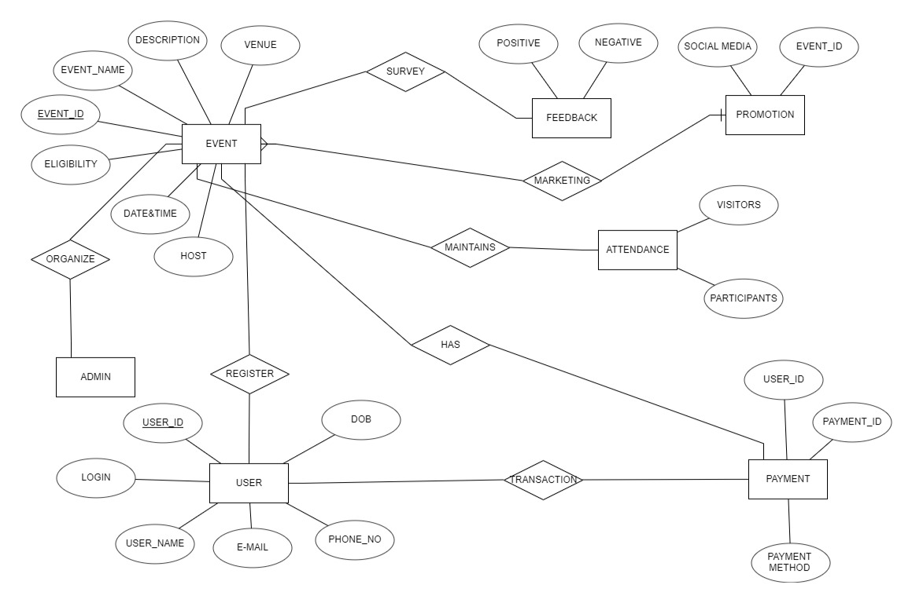

2.3 **User class and characteristics**

The system provides different types of services based on the type of Events.

It helps Admin to planning, organization, and execution of events.

The features that available for event organizer(Admin):

* Event Creation and Customization:
* Promotional Tools:
* Online Registration and Ticketing:
* Attendee Management:
* Payment Processing:
* Feedback and Surveys:

2.4 **Operating Environment**

The product will be operating in windows environment. The Library Management System is a website and shall operate in all famous browsers, for a model we are taking Microsoft Internet Explorer, Google Chrome, and Mozilla Firefox. Also it will be compatible with the IE 6.0. Most of the features will be compatible with the Mozilla Firefox & Opera 7.0 or higher version. The only requirement to use this online product would be the internet connection. The hardware configuration include Hard Disk: 40 GB, Monitor: 15” Colour monitor, Keyboard: 122 keys. The basic input devices required are keyboard, mouse and output devices are monitor, printer etc.

2.5 **Assumptions and Dependencies**

**The assumptions are:-**

* + - The coding should be error free
    - The system should be user-friendly so that it is easy to use for the users
    - The information of all users, books and libraries must be stored in a database that is accessible by the website
    - The system should have more storage capacity and provide fast access to the database
    - The system should provide search facility and support quick transactions The Library System is running 24 hours a day
    - Users may access from any computer that has Internet browsing capabilities and an Internet connection
    - Users must have their correct usernames and passwords to enter into their online accounts and do actions

**The dependencies are:-**

* + - The specific hardware and software due to which the product will be run
    - On the basis of listing requirements and specification the project will be developed and run
    - The end users (admin) should have proper understanding of the product The system should have the general report stored
    - The information of all the users must be stored in a database that is accessible by the Library System
    - Any update regarding the book from the library is to be recorded to the database and the data entered should be correct

**2.6 Requirement**

**Software Configuration:-**

This software package is developed using java as front end which is supported by sun micro system. Microsoft SQL Server as the back end to store the database. Operating System: Windows NT, windows 98, Windows XP Language: Java Runtime Environment, Net beans 7.0.1 (front end) Database: MS SQL Server (back end)

Hardware Configuration:-

Processor: Pentium(R)Dual-core CPU

Hard Disk: 40GB

RAM: 256 MB or more

**2.7 Data Requirement**

The inputs consist of the query to the database and the output consists of the solutions for the query. The output also includes the user receiving the details of their accounts. In this project the inputs will be the queries as fired by the users like create an account, create an event and putting into account. Now the output will be visible when the user requests the server to get details of their account in the form of time, date and which event are currently in the account.

**3. External Interface Requirement**

**3.1 GUI**

* + - The software provides good graphical interface for the user and the administrator can operate on the system, performing the required task such as create, update, viewing the details of the event.
    - It allows user to view quick reports of Event in between particular time.
    - It provides search facility based on different criteria.
    - The user interface must be customizable by the administrator
    - All the modules provided with the software must fit into this graphical user interface and accomplish to the standard defined
    - The design should be simple and all the different interfaces should follow a standard template
    - The user interface should be able to interact with the user management module and a part of the interface must be dedicated to the login/logout module

**4. System Features**

### 1.Distributed Audience Management:

### Feature: Centralized handling of diverse audiences.

### Dev Speak: Unified audience management on a single platform.

### 2.Local Hardware Support for In-Person Events:

### Feature: In-person event hardware integration.

### Dev Speak: Localized hardware support for seamless on-site events.

### 3.White Label Branding:

### Feature: Customizable branding for client identity.

### Dev Speak: White label support for personalized client branding.

### 4.Effortless Event Registration & Check-In:

### Feature: Simplified on-site and online registration and check-in.

### Dev Speak: Intuitive processes for hassle-free event entry.

### 5.Secure Event Ticketing:

### Feature: Ensured security in event ticketing processes.

### Dev Speak: Robust measures for safeguarding event ticket transactions.

### 6.Reports & Analytics:

### Feature: Comprehensive data analysis and reporting.

### Dev Speak: Robust analytics tools for insightful event metrics.

### 5. Other Non-functional Requirements

### 5.1 Performance Requirement

### The proposed system that we are going to develop will be used as the Chief performance system within the different location of the Events which interacts with the event organizer and participant. Therefore, it is expected that the database would perform functionally all the requirements that are specified by the organizer. The performance of the system should be fast and accurate Event Management System shall handle expected and non-expected errors in ways that prevent loss in information and long downtime period. Thus it should have inbuilt error testing to identify invalid username/password The system should be able to handle large amount of data. Thus it should accommodate high number of books and users without any fault.

### 5.2 Safety Requirement

### The database may get crashed at any certain time due to virus or operating system failure. Therefore, it is required to take the database backup so that the database is not lost. Proper UPS/inverter facility should be there in case of power supply failure.

### Security Requirement

### System will use secured database

### Normal users can just read information but they cannot edit or modify anything except their personal and some other information.

### System will have different types of users and every user has access constraints

### Proper user authentication should be provided no one should be able to hack users’ password

### There should be separate accounts for admin and members such that no member can access the database and only admin has the rights to update the database.

### Requirement attributes

### There may be multiple admins creating the project, all of them will have the right to create changes to the system. But the members or other users cannot do changes

### The project should be open source

### The Quality of the database is maintained in such a way so that it can be very user friendly to all the users of the database

### The user be able to easily download and install the system

### Business Rules

### A business rule is anything that captures and implements business policies and practices. A rule can enforce business policy, make a decision, or infer new data from existing data. This includes the rules and regulations that the System users should abide by. This includes the cost of the project and the discount offers provided. The users should avoid illegal rules and protocols. Neither admin nor member should cross the rules and regulations.

### 

### 5.6 User Requirements

### User Profiles:

### Members: Basic computer and internet skills.

### Administrators: In-depth understanding for system management.

### User Interface and Education:

### User Proficiency: Intuitive interface for basic computer literacy.

### Administrator Knowledge: Access to comprehensive manuals, online help, and installation guides.

### Administrator Facilities:

### Backup and Recovery: Robust features for safeguarding critical event data.

### Forgot Password: User-friendly recovery mechanism for seamless access.

### Data Migration: Efficient storage of user registration data on the server.

### Data Replication: Ensure data redundancy across branches.

### Auto Recovery: Implement auto-saving to prevent data loss.

### File Organization: Facilitate effective event-related information management.

### Server Maintenance: Regular updates for enhanced system performance.

### Documentation and Training:

### User Education: Clear guides for user understanding.

### Troubleshooting: Equip administrators with guides for issue resolution.

### 6.Other Requirement

### 6.1 Exciting Requirements

### These requirements are for features that go beyond the customer's expectations and prove to be very satisfying when present.

### 1. Even unauthenticated users can view a calendar with the information of public holidays.

### 2. The user interface should provide appropriate error messages for invalid input.

### 3. The user interface should follow standard web practices such that the web interface is consistent with typical internet applications

### 6.2 Data and Category Requirement

### There are different categories of users namely Admin, Events, Designation etc. Depending upon the category of user the access rights are decided. It means if the user is an administrator then he can be able to modify the data, delete, append etc. All other users except the Event organizer only have the rights to retrieve the information about database. Similarly there will be different Events. According to the categories of event their relevant data should be displayed. The categories and the data related to each category should be coded in the particular format.

### 6.3 Appendix

### A: Admin, Abbreviation, Acronym, Assumptions; B: Books, Business rules; C: Class, Client, Conventions; D: Data requirement, Dependencies; G: GUI; K: Key; L: Library, Librarian; M: Member; N: Non-functional Requirement; O: Operating environment; P: Performance, Perspective, Purpose; R: Requirement, Requirement attributes; S: Safety, Scope, Security, System features; U: User, User class and characteristics, User requirement;

### 6.4 Glossary

### The following are the list of conventions and acronyms used in this document and the project as well:

### Administrator: A login id representing a user with user administration privileges to the software

### User: A general login id assigned to most users

### Client: Intended users for the software

### SQL: Structured Query Language; used to retrieve information from a database

### SQL Server: A server used to store data in an organized format

### Layer: Represents a section of the project

### User Interface Layer: The section of the assignment referring to what the user interacts with directly

### Application Logic Layer: The section of the assignment referring to the Web Server. This is where all computations are completed

### Data Storage Layer: The section of the assignment referring to where all data is recorded

### Use Case: A broad level diagram of the project showing a basic overview

### Class diagram: It is a type of static structure diagram that describes the structure of a system by showing the system’s cases, their attributes, and the relationships between the classes

### Interface: Something used to communicate across different mediums

### Unique Key: Used to differentiate entries in a database.

**6.5 Class Diagram**

### 